Declaration of Originality and Agreement

I/We hereby certify that my/our manuscript titled

is an original work of my/our own, except where indicated by referencing, and does not involve plagiarism. This manuscript has not been previously published nor simultaneously submitted to any other publication. I/we will professionally wait and comply with the review process, and not for any reason withdraw the article before final decision, be it rejected or accepted for publication. Otherwise, I/we could be sued, and would accept any sanction, including being banned forever from the JEMA submission.

Please write full names of all authors.
One signature is sufficient to represent all the authors.

Main Author 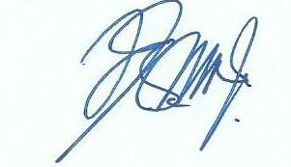
Isnaini Nuzula Agustin

____________________
December, 12, 2020

