Declaration of Originality and Agreement

I/We hereby certify that my/our manuscript titled “What are The Most Important Variables in Determining AirBnb Unit Prices in Yogyakarta?”

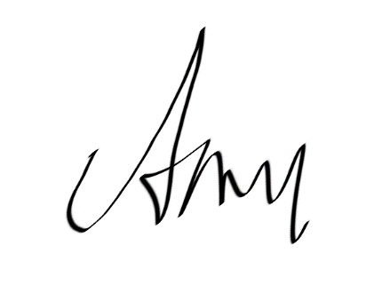
is an original work of my/our own, except where indicated by referencing, and does not involve plagiarism. This manuscript has not been previously published nor simultaneously submitted to any other publication. I/we will professionally wait and comply with the review process, and not for any reason withdraw the article before final decision, be it rejected or accepted for publication. Otherwise, I/we could be sued, and would accept any sanction, including being banned forever from the JEMA submission.

Main Author Signature
Andreas Diga Pratama Putera

____________________
December 21st, 2020

