LAMPIRAN

Correlations
 |  | X1.1 | X1.2 | X1.3 | X1.4 | X1.5 | X1.6 | X1.7 | Total_X1
X1.1 | Pearson Correlation | 1 | .433* | .522** | .150 | .734** | .623** | .552** | .816**
 | Sig. (2-tailed) |  | .017 | .003 | .430 | .000 | .000 | .002 | .000
 | N | 30 | 30 | 30 | 30 | 30 | 30 | 30 | 30
X1.2 | Pearson Correlation | .433* | 1 | .566** | .358 | .386* | .468** | .502** | .731**
 | Sig. (2-tailed) | .017 |  | .001 | .052 | .035 | .009 | .005 | .000
 | N | 30 | 30 | 30 | 30 | 30 | 30 | 30 | 30
X1.3 | Pearson Correlation | .522** | .566** | 1 | .430* | .367* | .581** | .305 | .770**
 | Sig. (2-tailed) | .003 | .001 |  | .018 | .046 | .001 | .101 | .000
 | N | 30 | 30 | 30 | 30 | 30 | 30 | 30 | 30
X1.4 | Pearson Correlation | .150 | .358 | .430* | 1 | .060 | .179 | .083 | .483**
 | Sig. (2-tailed) | .430 | .052 | .018 |  | .752 | .344 | .661 | .007
 | N | 30 | 30 | 30 | 30 | 30 | 30 | 30 | 30
X1.5 | Pearson Correlation | .734** | .386* | .367* | .060 | 1 | .599** | .409* | .714**
 | Sig. (2-tailed) | .000 | .035 | .046 | .752 |  | .000 | .025 | .000
 | N | 30 | 30 | 30 | 30 | 30 | 30 | 30 | 30
X1.6 | Pearson Correlation | .623** | .468** | .581** | .179 | .599** | 1 | .542** | .799**
 | Sig. (2-tailed) | .000 | .009 | .001 | .344 | .000 |  | .002 | .000
 | N | 30 | 30 | 30 | 30 | 30 | 30 | 30 | 30
X1.7 | Pearson Correlation | .552** | .502** | .305 | .083 | .409* | .542** | 1 | .647**
 | Sig. (2-tailed) | .002 | .005 | .101 | .661 | .025 | .002 |  | .000
 | N | 30 | 30 | 30 | 30 | 30 | 30 | 30 | 30
Total_X1 | Pearson Correlation | .816** | .731** | .770** | .483** | .714** | .799** | .647** | 1
 | Sig. (2-tailed) | .000 | .000 | .000 | .007 | .000 | .000 | .000
 | N | 30 | 30 | 30 | 30 | 30 | 30 | 30 | 30
*. Correlation is significant at the 0.05 level (2-tailed).
**. Correlation is significant at the 0.01 level (2-tailed).

Correlations
 |  | X2.8 | X2.9 | X2.10 | X2.11 | X2.12 | X2.13 | X2.14 | X2.15 | Total_X2
X2.8 | Pearson Correlation | 1 | .651** | .604** | .473** | .592** | .373* | .358 | .165 | .698**
 | Sig. (2-tailed) |  | .000 | .000 | .008 | .001 | .043 | .052 | .384 | .000
 | N | 30 | 30 | 30 | 30 | 30 | 30 | 30 | 30 | 30
X2.9 | Pearson Correlation | .651** | 1 | .530** | .560** | .726** | .574** | .507** | .427* | .836**
 | Sig. (2-tailed) | .000 |  | .003 | .001 | .000 | .001 | .004 | .018 | .000
 | N | 30 | 30 | 30 | 30 | 30 | 30 | 30 | 30 | 30
X2.10 | Pearson Correlation | .604** | .530** | 1 | .682** | .612** | .203 | .244 | .271 | .679**
 | Sig. (2-tailed) | .000 | .003 |  | .000 | .000 | .282 | .194 | .148 | .000
 | N | 30 | 30 | 30 | 30 | 30 | 30 | 30 | 30 | 30
X2.11 | Pearson Correlation | .473** | .560** | .682** | 1 | .817** | .260 | .315 | .236 | .707**
 | Sig. (2-tailed) | .008 | .001 | .000 |  | .000 | .166 | .090 | .210 | .000
 | N | 30 | 30 | 30 | 30 | 30 | 30 | 30 | 30 | 30
X2.12 | Pearson Correlation | .592** | .726** | .612** | .817** | 1 | .508** | .510** | .357 | .852**
 | Sig. (2-tailed) | .001 | .000 | .000 | .000 |  | .004 | .004 | .053 | .000
 | N | 30 | 30 | 30 | 30 | 30 | 30 | 30 | 30 | 30
X2.13 | Pearson Correlation | .373* | .574** | .203 | .260 | .508** | 1 | .731** | .618** | .750**
 | Sig. (2-tailed) | .043 | .001 | .282 | .166 | .004 |  | .000 | .000 | .000
 | N | 30 | 30 | 30 | 30 | 30 | 30 | 30 | 30 | 30
X2.14 | Pearson Correlation | .358 | .507** | .244 | .315 | .510** | .731** | 1 | .639** | .749**
 | Sig. (2-tailed) | .052 | .004 | .194 | .090 | .004 | .000 |  | .000 | .000
 | N | 30 | 30 | 30 | 30 | 30 | 30 | 30 | 30 | 30
X2.15 | Pearson Correlation | .165 | .427* | .271 | .236 | .357 | .618** | .639** | 1 | .645**
 | Sig. (2-tailed) | .384 | .018 | .148 | .210 | .053 | .000 | .000 |  | .000
 | N | 30 | 30 | 30 | 30 | 30 | 30 | 30 | 30 | 30
Total_X2 | Pearson Correlation | .698** | .836** | .679** | .707** | .852** | .750** | .749** | .645** | 1
 | Sig. (2-tailed) | .000 | .000 | .000 | .000 | .000 | .000 | .000 | .000
 | N | 30 | 30 | 30 | 30 | 30 | 30 | 30 | 30 | 30
**. Correlation is significant at the 0.01 level (2-tailed).
*. Correlation is significant at the 0.05 level (2-tailed).

Correlations
 |  | Y.16 | Y.17 | Y.18 | Y.19 | Y.20 | Total_Y
Y.16 | Pearson Correlation | 1 | .620** | .481** | .588** | .497** | .825**
 | Sig. (2-tailed) |  | .000 | .007 | .001 | .005 | .000
 | N | 30 | 30 | 30 | 30 | 30 | 30
Y.17 | Pearson Correlation | .620** | 1 | .616** | .474** | .396* | .816**
 | Sig. (2-tailed) | .000 |  | .000 | .008 | .030 | .000
 | N | 30 | 30 | 30 | 30 | 30 | 30
Y.18 | Pearson Correlation | .481** | .616** | 1 | .436* | .286 | .712**
 | Sig. (2-tailed) | .007 | .000 |  | .016 | .125 | .000
 | N | 30 | 30 | 30 | 30 | 30 | 30
Y.19 | Pearson Correlation | .588** | .474** | .436* | 1 | .600** | .798**
 | Sig. (2-tailed) | .001 | .008 | .016 |  | .000 | .000
 | N | 30 | 30 | 30 | 30 | 30 | 30
Y.20 | Pearson Correlation | .497** | .396* | .286 | .600** | 1 | .718**
 | Sig. (2-tailed) | .005 | .030 | .125 | .000 |  | .000
 | N | 30 | 30 | 30 | 30 | 30 | 30
Total_Y | Pearson Correlation | .825** | .816** | .712** | .798** | .718** | 1
 | Sig. (2-tailed) | .000 | .000 | .000 | .000 | .000
 | N | 30 | 30 | 30 | 30 | 30 | 30
**. Correlation is significant at the 0.01 level (2-tailed).
*. Correlation is significant at the 0.05 level (2-tailed).

Reliability Statistics
Cronbach's Alpha | Cronbach's Alpha Based on Standardized Items | N of Items
.828 | .836 | 7

Reliability Statistics
Cronbach's Alpha | Cronbach's Alpha Based on Standardized Items | N of Items
.879 | .882 | 8

Reliability Statistics
Cronbach's Alpha | Cronbach's Alpha Based on Standardized Items | N of Items
.832 | .833 | 5

One-Sample Kolmogorov-Smirnov Test
 |  | Unstandardized Residual
N |  | 85
Normal Parameters^{a,b} | Mean | .0000000
 | Std. Deviation | 1.73013937
Most Extreme Differences | Absolute | .076
 | Positive | .076
 | Negative | -.042
Test Statistic |  | .076
Asymp. Sig. (2-tailed) |  | .200^{c,d}
a. Test distribution is Normal.
b. Calculated from data.
c. Lilliefors Significance Correction.
d. This is a lower bound of the true significance.

Coefficientsª
Model |  | Unstandardized Coefficients |  | Standardized Coefficients | t | Sig. | Collinearity Statistics
 |  | B | Std. Error | Beta |  |  | Tolerance | VIF
1 | (Constant) | 4.889 | 1.202 |  | 4.066 | .000
 | TERPAAN IKLAN (X1) | .273 | .055 | .410 | 4.975 | .000 | .669 | 1.494
 | BRAND LOYALTY (X2) | .257 | .044 | .482 | 5.853 | .000 | .669 | 1.494
a. Dependent Variable: MINAT BELI (Y)

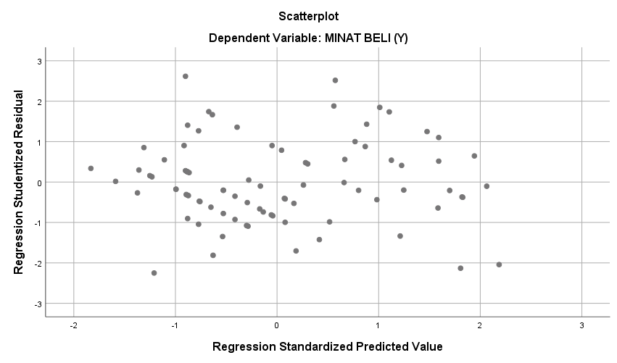
Coefficientsª
Model |  | Unstandardized Coefficients |  | Standardized Coefficients | t | Sig.
 |  | B | Std. Error | Beta
1 | (Constant) | 7.025 | 1.356 |  | 5.180 | .000
 | TERPAAN IKLAN (X1) | .458 | .053 | .687 | 8.612 | .000
a. Dependent Variable: MINAT BELI (Y)

Model Summary
Model | R | R Square | Adjusted R Square | Std. Error of the Estimate
1 | .687ª | .472 | .466 | 2.073
a. Predictors: (Constant), TERPAAN IKLAN (X1)

Coefficientsª
Model |  | Unstandardized Coefficients |  | Standardized Coefficients | t | Sig.
 |  | B | Std. Error | Beta
1 | (Constant) | 8.762 | 1.084 |  | 8.084 | .000
 | BRAND LOYALTY (X2) | .371 | .040 | .700 | 9.197 | .000
a. Dependent Variable: MINAT BELI (Y)

Model Summary
Model | R | R Square | Adjusted R Square | Std. Error of the Estimate
1 | .700ª | .490 | .484 | 2.032
a. Predictors: (Constant), BRAND LOYALTY (X2)

Coefficientsª
Model |  | Unstandardized Coefficients |  | Standardized Coefficients | t | Sig. | Collinearity Statistics
 |  | B | Std. Error | Beta |  |  | Tolerance | VIF
1 | (Constant) | 4.889 | 1.202 |  | 4.066 | .000
 | TERPAAN IKLAN (X1) | .273 | .055 | .410 | 4.975 | .000 | .669 | 1.494
 | BRAND LOYALTY (X2) | .257 | .044 | .482 | 5.853 | .000 | .669 | 1.494
a. Dependent Variable: MINAT BELI (Y)

Model Summary^{b}
Model | R | R Square | Adjusted R Square | Std. Error of the Estimate
1 | .792ª | .628 | .618 | 1.751
a. Predictors: (Constant), BRAND LOYALTY (X2), TERPAAN IKLAN (X1)
b. Dependent Variable: MINAT BELI (Y)

ANOVAª
Model |  | Sum of Squares | df | Mean Square | F | Sig.
1 | Regression | 423.662 | 2 | 211.831 | 69.081 | .000^{b}
 | Residual | 251.444 | 82 | 3.066
 | Total | 675.106 | 84
a. Dependent Variable: MINAT BELI (Y)
b. Predictors: (Constant), BRAND LOYALTY (X2), TERPAAN IKLAN (X1)

