Declaration of Originality and Agreement

I hereby certify that my manuscript titled Optimal Portfolio Construction: Application of Sharpe's Single-Index Model on Dhaka Stock Exchange is an original work of my own, except where indicated by referencing, and does not involve plagiarism. This manuscript has not been previously published nor simultaneously submitted to any other publication. I will professionally wait and comply with the review process, and not for any reason withdraw the article before final decision, be it rejected or accepted for publication. Otherwise, I could be sued, and would accept any sanction, including being banned forever from the JEMA submission.

Please write full names of all authors.
One signature is sufficient to represent all the authors.

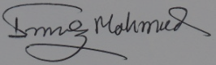
Main Author [Imroz Mahmud] Signature

____________________
12/31/2018

